**Project Initialization and Planning Phase**

| Date | 7 November 2024 |
| --- | --- |
| Team ID | 739939 |
| Project Name | Image Caption Generator |
| Maximum Marks | 3 Marks |

**Define Problem Statements (Customer Problem Statement Template):**

Create a problem statement to understand your customer's point of view. The Customer Problem Statement template helps you focus on what matters to create experiences people will love. A well-articulated customer problem statement allows you and your team to find the ideal solution for your customers' challenges. Throughout the process, you’ll also be able to empathize with your customers, which helps you better understand how they perceive your product or service.

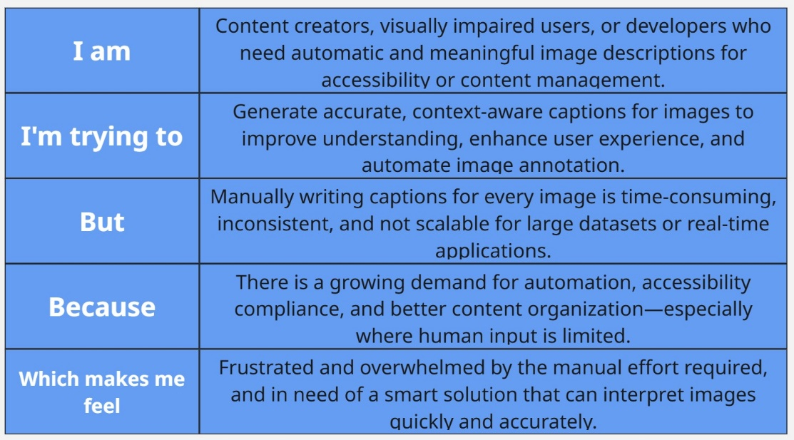

**Example:**

|  |  |  |  |  |  |  |
| --- | --- | --- | --- | --- | --- | --- |
| **Problem**  **Statement (PS)** | **I am**  **(Customer)** | **I’m trying to** | **But** |  | **Because** | **Which makes me feel** |
| PS-1 | A content manager responsible for organizing and publishing large volumes of image-based content on websites and social media platforms. | Needs to generate accurate and meaningful captions for each image to enhance accessibility, SEO, and user engagement. | Manual captioning is time-consuming, inconsistent, and not scalable for large content repositories. |  | Human-generated captions can vary in quality, take up significant time, and may miss key elements within the image. | Overwhelmed and frustrated by the repetitive work and quality issues, wishing for an automated system to generate reliable captions. |
| PS-2 | A developer working on an application for visually impaired users that requires descriptive audio or text for all visual content. | Wants to provide users with instant and accurate descriptions of images for better accessibility and user independence. | Manually creating captions for every new image uploaded is impractical and not feasible in real-time environments. |  | The lack of scalable solutions and the challenge of capturing visual context accurately in natural language. | Concerned about accessibility gaps and the inability to support users effectively without a dynamic captioning solution. |